Application Deployment — Submission
Deploy the given React application to a production-ready state

1. Key Links & Artifacts
GitHub Repository: https://github.com/jeevanantham2205/devops-build
Deployed Site URL: http://43.205.115.125
Docker Images:
- Dev (public): docker.io/jeeva22893/trend-app-dev
- Prod (private): docker.io/jeeva22893/trend-app-prod
Branches:
- dev — builds and pushes to trend-app-dev, auto-deploys to the app server
- main — builds and pushes to trend-app-prod, auto-deploys to the app server

2. Jenkins Screenshots

2.1 Login Page
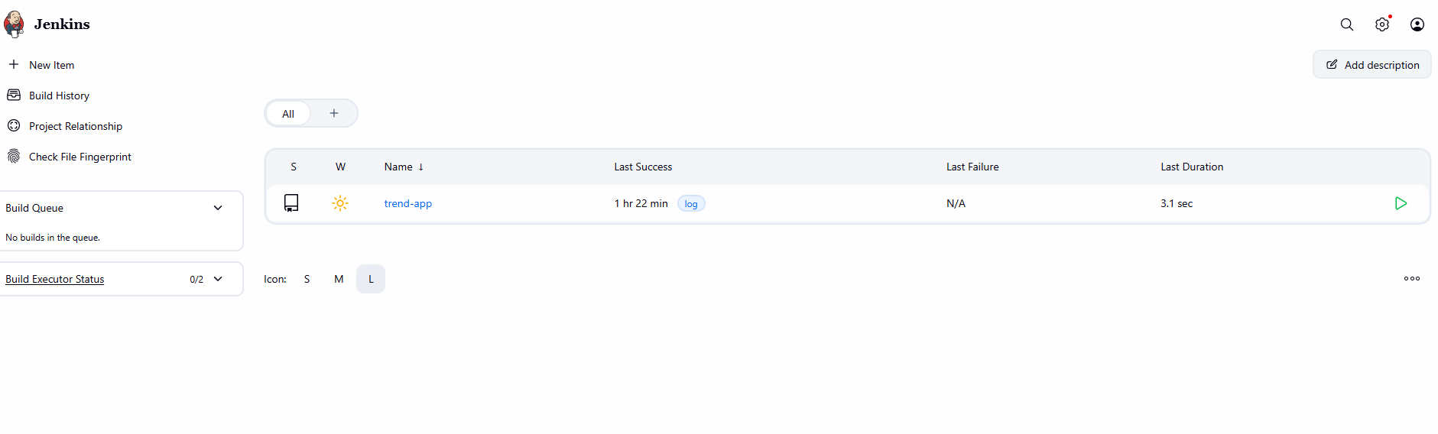

2.2 Configuration Settings
Credentials configured for GitHub API access and Docker Hub push access:
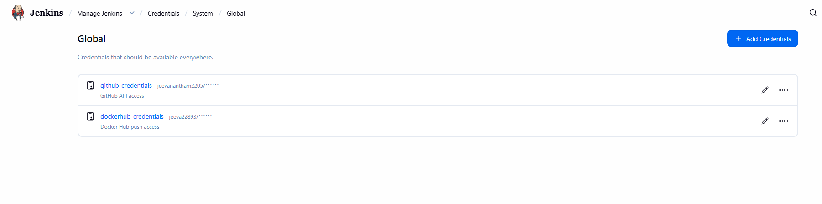

Jenkins → Manage Jenkins → Credentials → Global — github-credentials and dockerhub-credentials

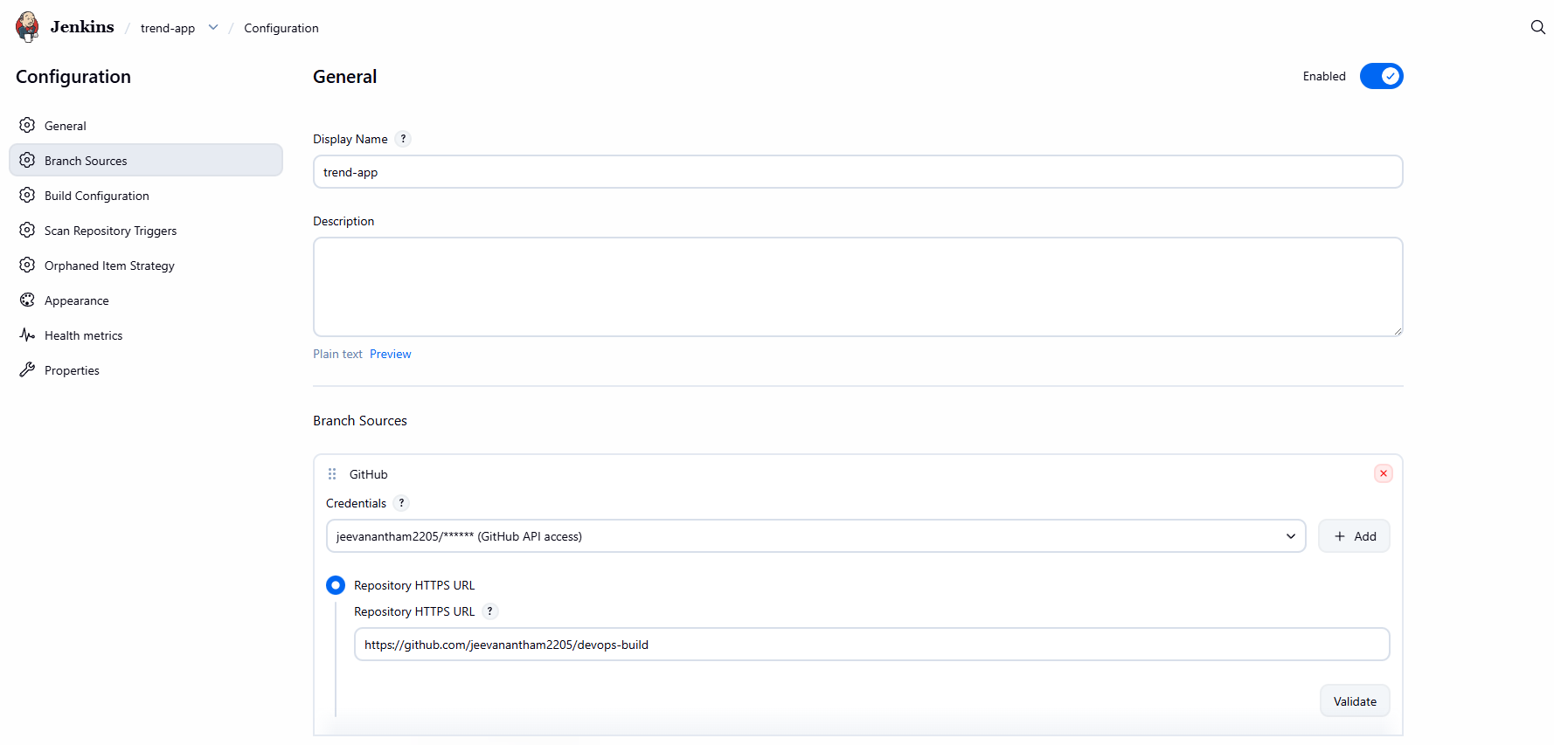

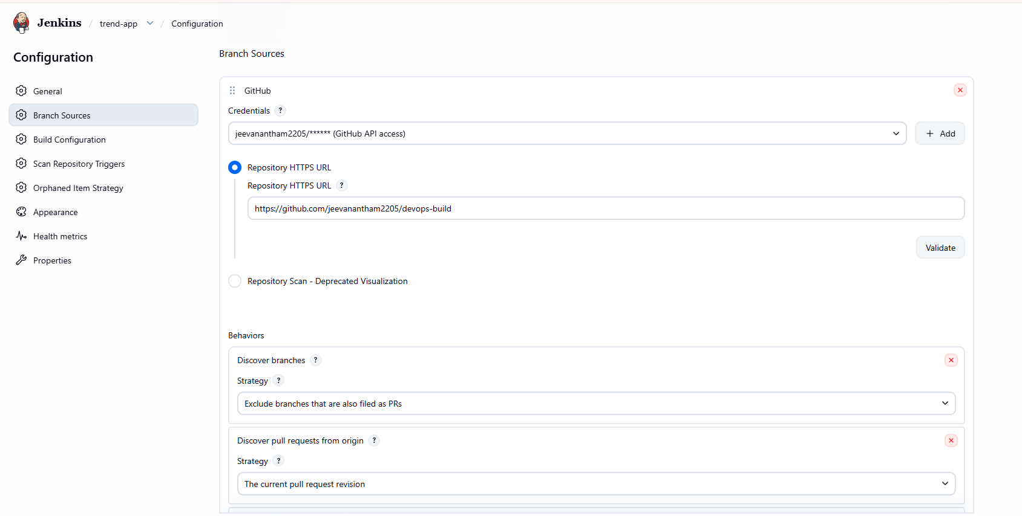

2.3 Execute / Build Steps
Console output of a successful build for the dev branch:
Started by user Jeevanantham02:17:10 Connecting to https://api.github.com using jeevanantham2205/****** (GitHub API access)Obtained Jenkinsfile from d7535a1859db3663d412a436a107ee77c46d3d32[Pipeline] Start of Pipeline[Pipeline] nodeRunning on Jenkins in /var/lib/jenkins/workspace/trend-app_dev[Pipeline] {[Pipeline] stage[Pipeline] { (Declarative: Checkout SCM)[Pipeline] checkoutThe recommended git tool is: NONE
using credential github-credentials
> git rev-parse --resolve-git-dir /var/lib/jenkins/workspace/trend-app_dev/.git # timeout=10
Fetching changes from the remote Git repository
> git config remote.origin.url https://github.com/jeevanantham2205/devops-build.git # timeout=10
Fetching without tags
Fetching upstream changes from https://github.com/jeevanantham2205/devops-build.git
> git --version # timeout=10
> git --version # 'git version 2.53.0'
using GIT_ASKPASS to set credentials GitHub API access
> git fetch --no-tags --force --progress -- https://github.com/jeevanantham2205/devops-build.git +refs/heads/dev:refs/remotes/origin/dev # timeout=10
Checking out Revision d7535a1859db3663d412a436a107ee77c46d3d32 (dev)
> git config core.sparsecheckout # timeout=10
> git checkout -f d7535a1859db3663d412a436a107ee77c46d3d32 # timeout=10
Commit message: "Add Jenkinsfile"
> git rev-list --no-walk d7535a1859db3663d412a436a107ee77c46d3d32 # timeout=10[Pipeline] }[Pipeline] // stage[Pipeline] withEnv[Pipeline] {[Pipeline] withEnv[Pipeline] {[Pipeline] stage[Pipeline] { (Checkout)[Pipeline] checkoutThe recommended git tool is: NONE
using credential github-credentials
> git rev-parse --resolve-git-dir /var/lib/jenkins/workspace/trend-app_dev/.git # timeout=10
Fetching changes from the remote Git repository
> git config remote.origin.url https://github.com/jeevanantham2205/devops-build.git # timeout=10
Fetching without tags
Fetching upstream changes from https://github.com/jeevanantham2205/devops-build.git
> git --version # timeout=10
> git --version # 'git version 2.53.0'
using GIT_ASKPASS to set credentials GitHub API access
> git fetch --no-tags --force --progress -- https://github.com/jeevanantham2205/devops-build.git +refs/heads/dev:refs/remotes/origin/dev # timeout=10
Checking out Revision d7535a1859db3663d412a436a107ee77c46d3d32 (dev)
> git config core.sparsecheckout # timeout=10
> git checkout -f d7535a1859db3663d412a436a107ee77c46d3d32 # timeout=10
Commit message: "Add Jenkinsfile"[Pipeline] }[Pipeline] // stage[Pipeline] stage[Pipeline] { (Determine target repo)[Pipeline] script[Pipeline] {[Pipeline] }[Pipeline] // script[Pipeline] }[Pipeline] // stage[Pipeline] stage[Pipeline] { (Docker Build)[Pipeline] sh+ docker build -t jeeva22893/trend-app-dev:7 -t jeeva22893/trend-app-dev:latest .
DEPRECATED: The legacy builder is deprecated and will be removed in a future release.
Install the buildx component to build images with BuildKit:
https://docs.docker.com/go/buildx/

Sending build context to Docker daemon 2.626MB

Step 1/6 : FROM nginx:alpine
---> db35bfc6b295
Step 2/6 : RUN rm -rf /usr/share/nginx/html/*
---> Using cache
---> c71be81f613b
Step 3/6 : COPY build/ /usr/share/nginx/html/
---> Using cache
---> b0a4971cbb6f
Step 4/6 : COPY nginx.conf /etc/nginx/conf.d/default.conf
---> Using cache
---> ef68ef0da8c0
Step 5/6 : EXPOSE 80
---> Using cache
---> b473399938be
Step 6/6 : CMD ["nginx", "-g", "daemon off;"]
---> Using cache
---> 8169e2365bfa
Successfully built 8169e2365bfa
Successfully tagged jeeva22893/trend-app-dev:7
Successfully tagged jeeva22893/trend-app-dev:latest[Pipeline] }[Pipeline] // stage[Pipeline] stage[Pipeline] { (Docker Login & Push)[Pipeline] withCredentialsMasking supported pattern matches of $DOCKER_PASS[Pipeline] {[Pipeline] sh+ echo ****
+ docker login -u jeeva22893 --password-stdin
Login Succeeded
+ docker push jeeva22893/trend-app-dev:7
The push refers to repository [docker.io/jeeva22893/trend-app-dev]
8cdfe4f23778: Waiting
da4dea1b00af: Waiting
622d12d99f66: Waiting
680627abc169: Waiting
55afa1ecc21d: Waiting
0ea935727878: Waiting
fb597529c916: Waiting
807b65f760c0: Waiting
0d62d88506ba: Waiting
d94291c26261: Waiting
1ed8e39a7434: Waiting
680627abc169: Waiting
55afa1ecc21d: Waiting
0ea935727878: Waiting
fb597529c916: Waiting
807b65f760c0: Waiting
0d62d88506ba: Waiting
d94291c26261: Waiting
1ed8e39a7434: Waiting
8cdfe4f23778: Waiting
da4dea1b00af: Waiting
622d12d99f66: Waiting
807b65f760c0: Waiting
0d62d88506ba: Waiting
d94291c26261: Waiting
1ed8e39a7434: Waiting
8cdfe4f23778: Waiting
da4dea1b00af: Waiting
622d12d99f66: Waiting
680627abc169: Waiting
55afa1ecc21d: Waiting
0ea935727878: Waiting
fb597529c916: Waiting
622d12d99f66: Waiting
680627abc169: Waiting
55afa1ecc21d: Waiting
0ea935727878: Waiting
fb597529c916: Waiting
807b65f760c0: Waiting
0d62d88506ba: Waiting
d94291c26261: Waiting
1ed8e39a7434: Waiting
8cdfe4f23778: Waiting
da4dea1b00af: Waiting
807b65f760c0: Waiting
0d62d88506ba: Waiting
d94291c26261: Waiting
1ed8e39a7434: Waiting
8cdfe4f23778: Waiting
da4dea1b00af: Waiting
622d12d99f66: Waiting
680627abc169: Waiting
55afa1ecc21d: Waiting
0ea935727878: Waiting
fb597529c916: Waiting
0d62d88506ba: Waiting
d94291c26261: Waiting
1ed8e39a7434: Waiting
8cdfe4f23778: Waiting
da4dea1b00af: Waiting
622d12d99f66: Waiting
680627abc169: Waiting
55afa1ecc21d: Waiting
0ea935727878: Waiting
fb597529c916: Waiting
807b65f760c0: Waiting
680627abc169: Waiting
55afa1ecc21d: Waiting
0ea935727878: Waiting
fb597529c916: Waiting
807b65f760c0: Waiting
0d62d88506ba: Waiting
d94291c26261: Waiting
1ed8e39a7434: Waiting
8cdfe4f23778: Waiting
da4dea1b00af: Waiting
622d12d99f66: Waiting
0d62d88506ba: Waiting
d94291c26261: Waiting
1ed8e39a7434: Waiting
8cdfe4f23778: Waiting
da4dea1b00af: Waiting
622d12d99f66: Waiting
680627abc169: Waiting
55afa1ecc21d: Waiting
0ea935727878: Waiting
fb597529c916: Waiting
807b65f760c0: Waiting
55afa1ecc21d: Waiting
0ea935727878: Waiting
fb597529c916: Waiting
807b65f760c0: Waiting
0d62d88506ba: Waiting
d94291c26261: Waiting
1ed8e39a7434: Waiting
8cdfe4f23778: Waiting
da4dea1b00af: Waiting
622d12d99f66: Waiting
680627abc169: Waiting
807b65f760c0: Waiting
0d62d88506ba: Waiting
d94291c26261: Waiting
1ed8e39a7434: Waiting
8cdfe4f23778: Waiting
da4dea1b00af: Waiting
622d12d99f66: Waiting
680627abc169: Waiting
55afa1ecc21d: Waiting
0ea935727878: Waiting
fb597529c916: Waiting
d94291c26261: Waiting
1ed8e39a7434: Waiting
8cdfe4f23778: Waiting
da4dea1b00af: Waiting
622d12d99f66: Waiting
680627abc169: Waiting
55afa1ecc21d: Waiting
0ea935727878: Waiting
fb597529c916: Waiting
807b65f760c0: Waiting
0d62d88506ba: Waiting
807b65f760c0: Waiting
0d62d88506ba: Waiting
d94291c26261: Waiting
1ed8e39a7434: Waiting
8cdfe4f23778: Waiting
da4dea1b00af: Waiting
622d12d99f66: Waiting
680627abc169: Waiting
55afa1ecc21d: Waiting
0ea935727878: Waiting
fb597529c916: Waiting
807b65f760c0: Waiting
0d62d88506ba: Waiting
d94291c26261: Waiting
1ed8e39a7434: Waiting
8cdfe4f23778: Waiting
da4dea1b00af: Waiting
622d12d99f66: Waiting
680627abc169: Waiting
55afa1ecc21d: Waiting
0ea935727878: Waiting
fb597529c916: Waiting
0ea935727878: Waiting
fb597529c916: Waiting
807b65f760c0: Waiting
0d62d88506ba: Waiting
d94291c26261: Waiting
1ed8e39a7434: Waiting
8cdfe4f23778: Waiting
da4dea1b00af: Waiting
622d12d99f66: Waiting
680627abc169: Waiting
55afa1ecc21d: Waiting
0d62d88506ba: Waiting
d94291c26261: Waiting
1ed8e39a7434: Waiting
8cdfe4f23778: Waiting
da4dea1b00af: Waiting
622d12d99f66: Waiting
680627abc169: Waiting
55afa1ecc21d: Waiting
0ea935727878: Waiting
fb597529c916: Waiting
8cdfe4f23778: Waiting
da4dea1b00af: Waiting
622d12d99f66: Waiting
680627abc169: Waiting
55afa1ecc21d: Waiting
0ea935727878: Waiting
fb597529c916: Waiting
0d62d88506ba: Waiting
d94291c26261: Waiting
1ed8e39a7434: Waiting
0d62d88506ba: Waiting
d94291c26261: Waiting
1ed8e39a7434: Waiting
8cdfe4f23778: Waiting
da4dea1b00af: Waiting
55afa1ecc21d: Waiting
0ea935727878: Waiting
fb597529c916: Waiting
0d62d88506ba: Waiting
d94291c26261: Waiting
1ed8e39a7434: Waiting
8cdfe4f23778: Waiting
da4dea1b00af: Waiting
55afa1ecc21d: Waiting
0ea935727878: Waiting
fb597529c916: Waiting
55afa1ecc21d: Waiting
0ea935727878: Waiting
fb597529c916: Waiting
0d62d88506ba: Waiting
d94291c26261: Waiting
1ed8e39a7434: Waiting
8cdfe4f23778: Waiting
da4dea1b00af: Waiting
0d62d88506ba: Waiting
d94291c26261: Waiting
1ed8e39a7434: Waiting
8cdfe4f23778: Mounted from library/nginx
da4dea1b00af: Waiting
55afa1ecc21d: Waiting
0ea935727878: Mounted from library/nginx
fb597529c916: Waiting
0d62d88506ba: Waiting
d94291c26261: Waiting
1ed8e39a7434: Waiting
da4dea1b00af: Waiting
55afa1ecc21d: Waiting
fb597529c916: Waiting
d94291c26261: Waiting
1ed8e39a7434: Mounted from library/nginx
da4dea1b00af: Waiting
55afa1ecc21d: Waiting
fb597529c916: Mounted from library/nginx
0d62d88506ba: Waiting
55afa1ecc21d: Waiting
807b65f760c0: Pushed
0d62d88506ba: Waiting
d94291c26261: Mounted from library/nginx
da4dea1b00af: Mounted from library/nginx
0d62d88506ba: Mounted from library/nginx
622d12d99f66: Pushed
55afa1ecc21d: Mounted from library/nginx
680627abc169: Pushed
7: digest: sha256:8169e2365bfa3ab437eb10c4c8d277aa1ad9f9926f874e176b45cd04c83cae13 size: 2698
+ docker push jeeva22893/trend-app-dev:latest
The push refers to repository [docker.io/jeeva22893/trend-app-dev]
0d62d88506ba: Waiting
da4dea1b00af: Waiting
fb597529c916: Waiting
55afa1ecc21d: Waiting
d94291c26261: Waiting
807b65f760c0: Waiting
8cdfe4f23778: Waiting
622d12d99f66: Waiting
680627abc169: Waiting
1ed8e39a7434: Waiting
0ea935727878: Waiting
da4dea1b00af: Waiting
fb597529c916: Waiting
55afa1ecc21d: Waiting
d94291c26261: Waiting
807b65f760c0: Waiting
8cdfe4f23778: Waiting
622d12d99f66: Waiting
680627abc169: Waiting
1ed8e39a7434: Waiting
0ea935727878: Waiting
0d62d88506ba: Waiting
807b65f760c0: Waiting
8cdfe4f23778: Waiting
622d12d99f66: Waiting
680627abc169: Waiting
1ed8e39a7434: Waiting
0ea935727878: Waiting
0d62d88506ba: Waiting
da4dea1b00af: Waiting
fb597529c916: Waiting
55afa1ecc21d: Waiting
d94291c26261: Waiting
55afa1ecc21d: Waiting
d94291c26261: Waiting
807b65f760c0: Waiting
8cdfe4f23778: Waiting
622d12d99f66: Waiting
680627abc169: Waiting
1ed8e39a7434: Waiting
0ea935727878: Waiting
0d62d88506ba: Waiting
da4dea1b00af: Waiting
fb597529c916: Waiting
680627abc169: Waiting
1ed8e39a7434: Waiting
0ea935727878: Waiting
0d62d88506ba: Waiting
da4dea1b00af: Waiting
fb597529c916: Waiting
55afa1ecc21d: Waiting
d94291c26261: Waiting
807b65f760c0: Waiting
8cdfe4f23778: Waiting
622d12d99f66: Waiting
0ea935727878: Waiting
0d62d88506ba: Waiting
da4dea1b00af: Waiting
fb597529c916: Waiting
55afa1ecc21d: Waiting
d94291c26261: Waiting
807b65f760c0: Waiting
8cdfe4f23778: Waiting
622d12d99f66: Waiting
680627abc169: Waiting
1ed8e39a7434: Waiting
1ed8e39a7434: Waiting
0ea935727878: Waiting
0d62d88506ba: Waiting
da4dea1b00af: Waiting
fb597529c916: Waiting
55afa1ecc21d: Waiting
d94291c26261: Waiting
807b65f760c0: Waiting
8cdfe4f23778: Waiting
622d12d99f66: Waiting
680627abc169: Waiting
807b65f760c0: Waiting
8cdfe4f23778: Waiting
622d12d99f66: Waiting
680627abc169: Waiting
1ed8e39a7434: Waiting
0ea935727878: Waiting
0d62d88506ba: Waiting
da4dea1b00af: Waiting
fb597529c916: Waiting
55afa1ecc21d: Waiting
d94291c26261: Waiting
0ea935727878: Waiting
0d62d88506ba: Waiting
da4dea1b00af: Waiting
fb597529c916: Waiting
55afa1ecc21d: Waiting
d94291c26261: Waiting
807b65f760c0: Waiting
8cdfe4f23778: Waiting
622d12d99f66: Waiting
680627abc169: Waiting
1ed8e39a7434: Waiting
807b65f760c0: Waiting
8cdfe4f23778: Waiting
622d12d99f66: Waiting
680627abc169: Waiting
1ed8e39a7434: Waiting
0ea935727878: Waiting
0d62d88506ba: Layer already exists
da4dea1b00af: Waiting
fb597529c916: Waiting
55afa1ecc21d: Waiting
d94291c26261: Layer already exists
807b65f760c0: Waiting
8cdfe4f23778: Waiting
622d12d99f66: Waiting
680627abc169: Waiting
1ed8e39a7434: Waiting
0ea935727878: Waiting
da4dea1b00af: Waiting
fb597529c916: Waiting
55afa1ecc21d: Waiting
680627abc169: Layer already exists
1ed8e39a7434: Waiting
0ea935727878: Waiting
da4dea1b00af: Waiting
fb597529c916: Waiting
55afa1ecc21d: Layer already exists
807b65f760c0: Waiting
8cdfe4f23778: Waiting
622d12d99f66: Waiting
807b65f760c0: Waiting
8cdfe4f23778: Waiting
622d12d99f66: Waiting
1ed8e39a7434: Waiting
0ea935727878: Waiting
da4dea1b00af: Waiting
fb597529c916: Waiting
807b65f760c0: Layer already exists
8cdfe4f23778: Layer already exists
622d12d99f66: Layer already exists
1ed8e39a7434: Layer already exists
0ea935727878: Layer already exists
da4dea1b00af: Layer already exists
fb597529c916: Layer already exists
latest: digest: sha256:8169e2365bfa3ab437eb10c4c8d277aa1ad9f9926f874e176b45cd04c83cae13 size: 2698[Pipeline] }[Pipeline] // withCredentials[Pipeline] }[Pipeline] // stage[Pipeline] stage[Pipeline] { (Declarative: Post Actions)[Pipeline] echoPipeline succeeded![Pipeline] }[Pipeline] // stage[Pipeline] }[Pipeline] // withEnv[Pipeline] }[Pipeline] // withEnv[Pipeline] }[Pipeline] // node[Pipeline] End of Pipeline
GitHub has been notified of this commit’s build result

Finished: SUCCESS

Console output of a successful build for the main branch :
Started by user Jeevanantham04:18:07 Connecting to https://api.github.com using jeevanantham2205/****** (GitHub API access)Obtained Jenkinsfile from 95659497b0b46093773b9da1f5a38e0f85f83568[Pipeline] Start of Pipeline[Pipeline] nodeRunning on Jenkins in /var/lib/jenkins/workspace/trend-app_main[Pipeline] {[Pipeline] stage[Pipeline] { (Declarative: Checkout SCM)[Pipeline] checkoutThe recommended git tool is: NONE
using credential github-credentials
> git rev-parse --resolve-git-dir /var/lib/jenkins/workspace/trend-app_main/.git # timeout=10
Fetching changes from the remote Git repository
> git config remote.origin.url https://github.com/jeevanantham2205/devops-build.git # timeout=10
Fetching without tags
Fetching upstream changes from https://github.com/jeevanantham2205/devops-build.git
> git --version # timeout=10
> git --version # 'git version 2.53.0'
using GIT_ASKPASS to set credentials GitHub API access
> git fetch --no-tags --force --progress -- https://github.com/jeevanantham2205/devops-build.git +refs/heads/main:refs/remotes/origin/main # timeout=10
Checking out Revision 95659497b0b46093773b9da1f5a38e0f85f83568 (main)
> git config core.sparsecheckout # timeout=10
> git checkout -f 95659497b0b46093773b9da1f5a38e0f85f83568 # timeout=10
Commit message: "Fix branch check to use main instead of master"
> git rev-list --no-walk 95659497b0b46093773b9da1f5a38e0f85f83568 # timeout=10[Pipeline] }[Pipeline] // stage[Pipeline] withEnv[Pipeline] {[Pipeline] withEnv[Pipeline] {[Pipeline] stage[Pipeline] { (Checkout)[Pipeline] checkoutThe recommended git tool is: NONE
using credential github-credentials
> git rev-parse --resolve-git-dir /var/lib/jenkins/workspace/trend-app_main/.git # timeout=10
Fetching changes from the remote Git repository
> git config remote.origin.url https://github.com/jeevanantham2205/devops-build.git # timeout=10
Fetching without tags
Fetching upstream changes from https://github.com/jeevanantham2205/devops-build.git
> git --version # timeout=10
> git --version # 'git version 2.53.0'
using GIT_ASKPASS to set credentials GitHub API access
> git fetch --no-tags --force --progress -- https://github.com/jeevanantham2205/devops-build.git +refs/heads/main:refs/remotes/origin/main # timeout=10
Checking out Revision 95659497b0b46093773b9da1f5a38e0f85f83568 (main)
> git config core.sparsecheckout # timeout=10
> git checkout -f 95659497b0b46093773b9da1f5a38e0f85f83568 # timeout=10
Commit message: "Fix branch check to use main instead of master"[Pipeline] }[Pipeline] // stage[Pipeline] stage[Pipeline] { (Determine target repo)[Pipeline] script[Pipeline] {[Pipeline] }[Pipeline] // script[Pipeline] }[Pipeline] // stage[Pipeline] stage[Pipeline] { (Docker Build)[Pipeline] sh+ docker build -t jeeva22893/trend-app-prod:4 -t jeeva22893/trend-app-prod:latest .
DEPRECATED: The legacy builder is deprecated and will be removed in a future release.
Install the buildx component to build images with BuildKit:
https://docs.docker.com/go/buildx/

Sending build context to Docker daemon 2.627MB

Step 1/6 : FROM nginx:alpine
---> db35bfc6b295
Step 2/6 : RUN rm -rf /usr/share/nginx/html/*
---> Using cache
---> c71be81f613b
Step 3/6 : COPY build/ /usr/share/nginx/html/
---> Using cache
---> b0a4971cbb6f
Step 4/6 : COPY nginx.conf /etc/nginx/conf.d/default.conf
---> Using cache
---> ef68ef0da8c0
Step 5/6 : EXPOSE 80
---> Using cache
---> b473399938be
Step 6/6 : CMD ["nginx", "-g", "daemon off;"]
---> Using cache
---> 8169e2365bfa
Successfully built 8169e2365bfa
Successfully tagged jeeva22893/trend-app-prod:4
Successfully tagged jeeva22893/trend-app-prod:latest[Pipeline] }[Pipeline] // stage[Pipeline] stage[Pipeline] { (Docker Login & Push)[Pipeline] withCredentialsMasking supported pattern matches of $DOCKER_PASS[Pipeline] {[Pipeline] sh+ echo ****
+ docker login -u jeeva22893 --password-stdin
Login Succeeded
+ docker push jeeva22893/trend-app-prod:4
The push refers to repository [docker.io/jeeva22893/trend-app-prod]
0ea935727878: Waiting
622d12d99f66: Waiting
807b65f760c0: Waiting
8cdfe4f23778: Waiting
55afa1ecc21d: Waiting
fb597529c916: Waiting
1ed8e39a7434: Waiting
680627abc169: Waiting
0d62d88506ba: Waiting
da4dea1b00af: Waiting
d94291c26261: Waiting
55afa1ecc21d: Waiting
fb597529c916: Waiting
1ed8e39a7434: Waiting
680627abc169: Waiting
0d62d88506ba: Waiting
da4dea1b00af: Waiting
d94291c26261: Waiting
0ea935727878: Waiting
622d12d99f66: Waiting
807b65f760c0: Waiting
8cdfe4f23778: Waiting
0d62d88506ba: Waiting
da4dea1b00af: Waiting
d94291c26261: Waiting
0ea935727878: Waiting
622d12d99f66: Waiting
807b65f760c0: Waiting
8cdfe4f23778: Waiting
55afa1ecc21d: Waiting
fb597529c916: Waiting
1ed8e39a7434: Waiting
680627abc169: Waiting
8cdfe4f23778: Waiting
55afa1ecc21d: Waiting
fb597529c916: Waiting
1ed8e39a7434: Waiting
680627abc169: Waiting
0d62d88506ba: Waiting
da4dea1b00af: Waiting
d94291c26261: Waiting
0ea935727878: Waiting
622d12d99f66: Waiting
807b65f760c0: Waiting
807b65f760c0: Waiting
8cdfe4f23778: Waiting
55afa1ecc21d: Waiting
fb597529c916: Waiting
1ed8e39a7434: Waiting
680627abc169: Waiting
0d62d88506ba: Waiting
da4dea1b00af: Waiting
d94291c26261: Waiting
0ea935727878: Waiting
622d12d99f66: Waiting
680627abc169: Waiting
0d62d88506ba: Waiting
da4dea1b00af: Waiting
d94291c26261: Waiting
0ea935727878: Waiting
622d12d99f66: Waiting
807b65f760c0: Waiting
8cdfe4f23778: Waiting
55afa1ecc21d: Waiting
fb597529c916: Waiting
1ed8e39a7434: Waiting
807b65f760c0: Waiting
8cdfe4f23778: Waiting
55afa1ecc21d: Waiting
fb597529c916: Waiting
1ed8e39a7434: Waiting
680627abc169: Waiting
0d62d88506ba: Waiting
da4dea1b00af: Waiting
d94291c26261: Waiting
0ea935727878: Waiting
622d12d99f66: Waiting
1ed8e39a7434: Waiting
680627abc169: Waiting
0d62d88506ba: Waiting
da4dea1b00af: Waiting
d94291c26261: Waiting
0ea935727878: Waiting
622d12d99f66: Waiting
807b65f760c0: Waiting
8cdfe4f23778: Waiting
55afa1ecc21d: Waiting
fb597529c916: Waiting
680627abc169: Waiting
0d62d88506ba: Waiting
da4dea1b00af: Waiting
d94291c26261: Waiting
0ea935727878: Waiting
622d12d99f66: Waiting
807b65f760c0: Waiting
8cdfe4f23778: Waiting
55afa1ecc21d: Waiting
fb597529c916: Waiting
1ed8e39a7434: Waiting
0ea935727878: Waiting
622d12d99f66: Waiting
807b65f760c0: Waiting
8cdfe4f23778: Waiting
55afa1ecc21d: Waiting
fb597529c916: Waiting
1ed8e39a7434: Waiting
680627abc169: Waiting
0d62d88506ba: Waiting
da4dea1b00af: Waiting
d94291c26261: Waiting
8cdfe4f23778: Layer already exists
55afa1ecc21d: Waiting
fb597529c916: Waiting
1ed8e39a7434: Waiting
680627abc169: Waiting
0d62d88506ba: Waiting
da4dea1b00af: Waiting
d94291c26261: Waiting
0ea935727878: Waiting
622d12d99f66: Waiting
807b65f760c0: Layer already exists
622d12d99f66: Layer already exists
55afa1ecc21d: Waiting
fb597529c916: Layer already exists
1ed8e39a7434: Waiting
680627abc169: Waiting
0d62d88506ba: Waiting
da4dea1b00af: Waiting
d94291c26261: Waiting
0ea935727878: Waiting
55afa1ecc21d: Waiting
1ed8e39a7434: Waiting
680627abc169: Waiting
0d62d88506ba: Waiting
da4dea1b00af: Waiting
d94291c26261: Waiting
0ea935727878: Waiting
0d62d88506ba: Waiting
da4dea1b00af: Waiting
d94291c26261: Waiting
0ea935727878: Layer already exists
55afa1ecc21d: Layer already exists
1ed8e39a7434: Layer already exists
680627abc169: Layer already exists
0d62d88506ba: Layer already exists
da4dea1b00af: Layer already exists
d94291c26261: Layer already exists
4: digest: sha256:8169e2365bfa3ab437eb10c4c8d277aa1ad9f9926f874e176b45cd04c83cae13 size: 2698
+ docker push jeeva22893/trend-app-prod:latest
The push refers to repository [docker.io/jeeva22893/trend-app-prod]
da4dea1b00af: Waiting
fb597529c916: Waiting
d94291c26261: Waiting
680627abc169: Waiting
807b65f760c0: Waiting
55afa1ecc21d: Waiting
622d12d99f66: Waiting
0ea935727878: Waiting
1ed8e39a7434: Waiting
8cdfe4f23778: Waiting
0d62d88506ba: Waiting
0d62d88506ba: Waiting
da4dea1b00af: Waiting
fb597529c916: Waiting
d94291c26261: Waiting
680627abc169: Waiting
807b65f760c0: Waiting
55afa1ecc21d: Waiting
622d12d99f66: Waiting
0ea935727878: Waiting
1ed8e39a7434: Waiting
8cdfe4f23778: Waiting
1ed8e39a7434: Waiting
8cdfe4f23778: Waiting
0d62d88506ba: Waiting
da4dea1b00af: Waiting
fb597529c916: Waiting
d94291c26261: Waiting
680627abc169: Waiting
807b65f760c0: Waiting
55afa1ecc21d: Waiting
622d12d99f66: Waiting
0ea935727878: Waiting
fb597529c916: Waiting
d94291c26261: Waiting
680627abc169: Waiting
807b65f760c0: Waiting
55afa1ecc21d: Waiting
622d12d99f66: Waiting
0ea935727878: Waiting
1ed8e39a7434: Waiting
8cdfe4f23778: Waiting
0d62d88506ba: Waiting
da4dea1b00af: Waiting
0ea935727878: Waiting
1ed8e39a7434: Waiting
8cdfe4f23778: Waiting
0d62d88506ba: Waiting
da4dea1b00af: Waiting
fb597529c916: Waiting
d94291c26261: Waiting
680627abc169: Waiting
807b65f760c0: Waiting
55afa1ecc21d: Waiting
622d12d99f66: Waiting
0d62d88506ba: Waiting
da4dea1b00af: Waiting
fb597529c916: Waiting
d94291c26261: Waiting
680627abc169: Waiting
807b65f760c0: Waiting
55afa1ecc21d: Waiting
622d12d99f66: Waiting
0ea935727878: Waiting
1ed8e39a7434: Waiting
8cdfe4f23778: Waiting
d94291c26261: Waiting
680627abc169: Waiting
807b65f760c0: Waiting
55afa1ecc21d: Waiting
622d12d99f66: Waiting
0ea935727878: Waiting
1ed8e39a7434: Waiting
8cdfe4f23778: Waiting
0d62d88506ba: Waiting
da4dea1b00af: Waiting
fb597529c916: Waiting
622d12d99f66: Waiting
0ea935727878: Waiting
1ed8e39a7434: Waiting
8cdfe4f23778: Waiting
0d62d88506ba: Waiting
da4dea1b00af: Waiting
fb597529c916: Waiting
d94291c26261: Waiting
680627abc169: Waiting
807b65f760c0: Waiting
55afa1ecc21d: Waiting
0d62d88506ba: Waiting
da4dea1b00af: Waiting
fb597529c916: Waiting
d94291c26261: Waiting
680627abc169: Waiting
807b65f760c0: Waiting
55afa1ecc21d: Waiting
622d12d99f66: Waiting
0ea935727878: Waiting
1ed8e39a7434: Waiting
8cdfe4f23778: Waiting
0d62d88506ba: Waiting
da4dea1b00af: Waiting
fb597529c916: Waiting
d94291c26261: Waiting
680627abc169: Layer already exists
807b65f760c0: Waiting
55afa1ecc21d: Waiting
622d12d99f66: Waiting
0ea935727878: Layer already exists
1ed8e39a7434: Waiting
8cdfe4f23778: Waiting
807b65f760c0: Waiting
55afa1ecc21d: Waiting
622d12d99f66: Waiting
1ed8e39a7434: Waiting
8cdfe4f23778: Waiting
0d62d88506ba: Waiting
da4dea1b00af: Waiting
fb597529c916: Waiting
d94291c26261: Waiting
807b65f760c0: Waiting
55afa1ecc21d: Waiting
622d12d99f66: Layer already exists
1ed8e39a7434: Waiting
8cdfe4f23778: Waiting
0d62d88506ba: Waiting
da4dea1b00af: Waiting
fb597529c916: Waiting
d94291c26261: Waiting
fb597529c916: Waiting
d94291c26261: Waiting
807b65f760c0: Waiting
55afa1ecc21d: Waiting
1ed8e39a7434: Waiting
8cdfe4f23778: Waiting
0d62d88506ba: Waiting
da4dea1b00af: Waiting
da4dea1b00af: Layer already exists
fb597529c916: Waiting
d94291c26261: Waiting
807b65f760c0: Waiting
55afa1ecc21d: Layer already exists
1ed8e39a7434: Waiting
8cdfe4f23778: Waiting
0d62d88506ba: Layer already exists
fb597529c916: Layer already exists
d94291c26261: Layer already exists
807b65f760c0: Layer already exists
1ed8e39a7434: Layer already exists
8cdfe4f23778: Layer already exists
latest: digest: sha256:8169e2365bfa3ab437eb10c4c8d277aa1ad9f9926f874e176b45cd04c83cae13 size: 2698[Pipeline] }[Pipeline] // withCredentials[Pipeline] }[Pipeline] // stage[Pipeline] stage[Pipeline] { (Deploy)[Pipeline] sshagent[ssh-agent] Using credentials ubuntu (SSH access to app server)
$ ssh-agent
SSH_AUTH_SOCK=/var/lib/jenkins/.ssh/agent/s.ppBT4fCP2V.agent.LKl2AFD905
SSH_AGENT_PID=17696
Running ssh-add (command line suppressed)
[ssh-agent] Started.[Pipeline] {[Pipeline] sh+ ssh -o StrictHostKeyChecking=no ubuntu@43.205.115.125 docker pull jeeva22893/trend-app-prod:latest && \
docker stop trend-app || true && docker rm trend-app || true && \
docker run -d --name trend-app -p 80:80 --restart unless-stopped jeeva22893/trend-app-prod:latest
Warning: Permanently added '43.205.115.125' (ED25519) to the list of known hosts.
latest: Pulling from jeeva22893/trend-app-prod
Digest: sha256:8169e2365bfa3ab437eb10c4c8d277aa1ad9f9926f874e176b45cd04c83cae13
Status: Downloaded newer image for jeeva22893/trend-app-prod:latest
docker.io/jeeva22893/trend-app-prod:latest
trend-app
trend-app
0770bfad79137909c8660ab589f7dd2c45916901747b79e359a8caa579cccece[Pipeline] }$ ssh-agent -k
unset SSH_AUTH_SOCK;
unset SSH_AGENT_PID;
echo Agent pid 17696 killed;
[ssh-agent] Stopped.[Pipeline] // sshagent[Pipeline] }[Pipeline] // stage[Pipeline] stage[Pipeline] { (Declarative: Post Actions)[Pipeline] echoPipeline succeeded![Pipeline] }[Pipeline] // stage[Pipeline] }[Pipeline] // withEnv[Pipeline] }[Pipeline] // withEnv[Pipeline] }[Pipeline] // node[Pipeline] End of Pipeline
GitHub has been notified of this commit’s build result

Finished: SUCCESS

3. AWS Screenshots

3.1 EC2 Console

3.2 Security Group Configurations

App server security group — inbound rules (SSH restricted, HTTP open, monitoring port):

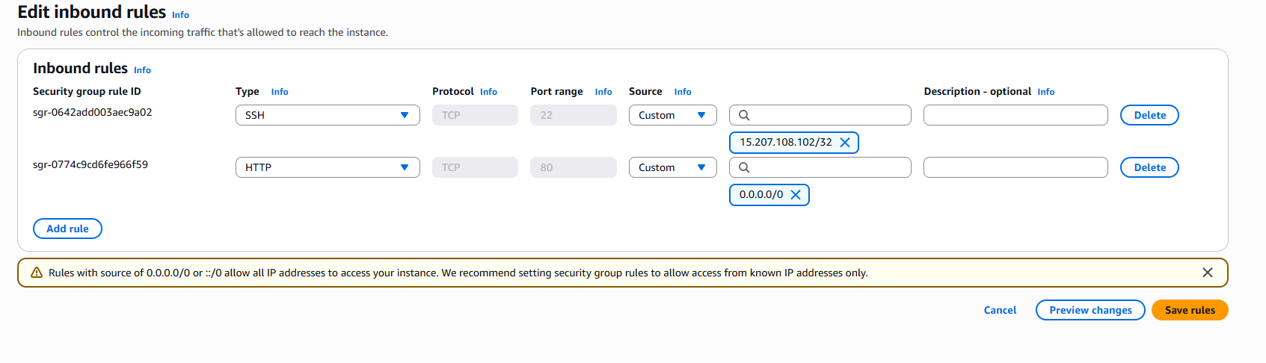

App server security group — editing inbound rules
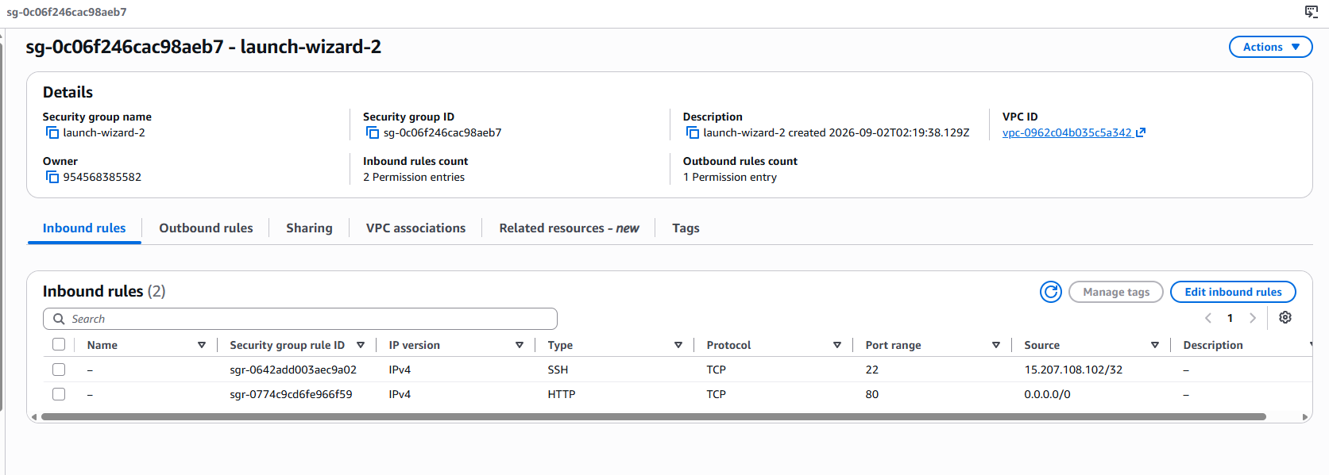
App server security group — details view
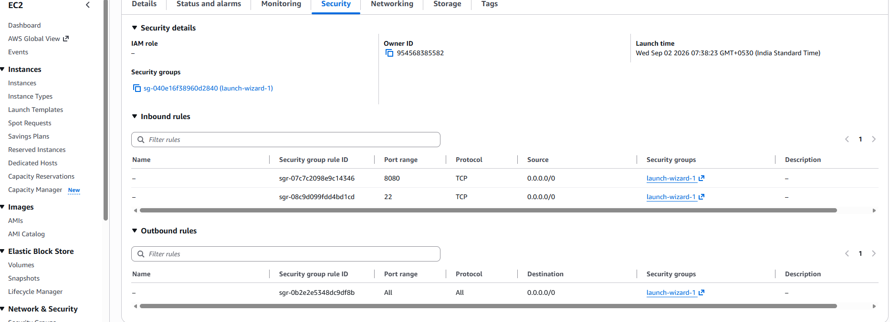

Docker Hub
Docker Hub repo page for trend-app-dev showing image tags (public) ]
Docker Hub repo page for trend-app-prod showing image tags (private) ]

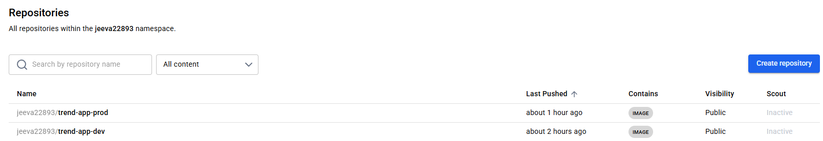
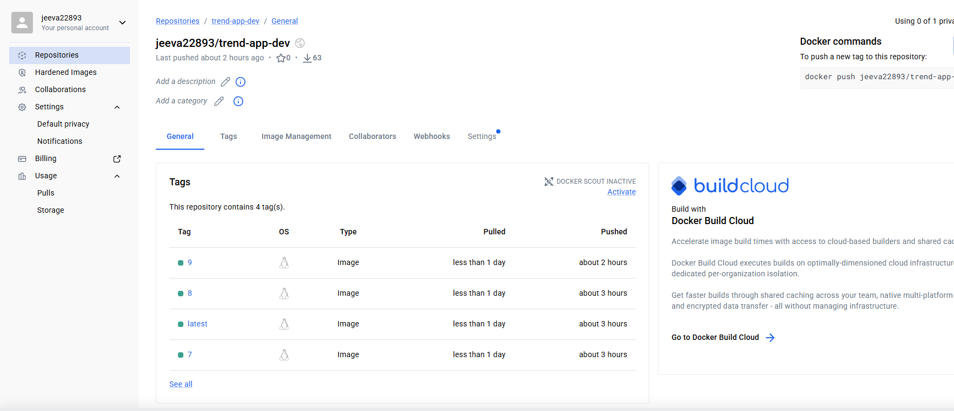
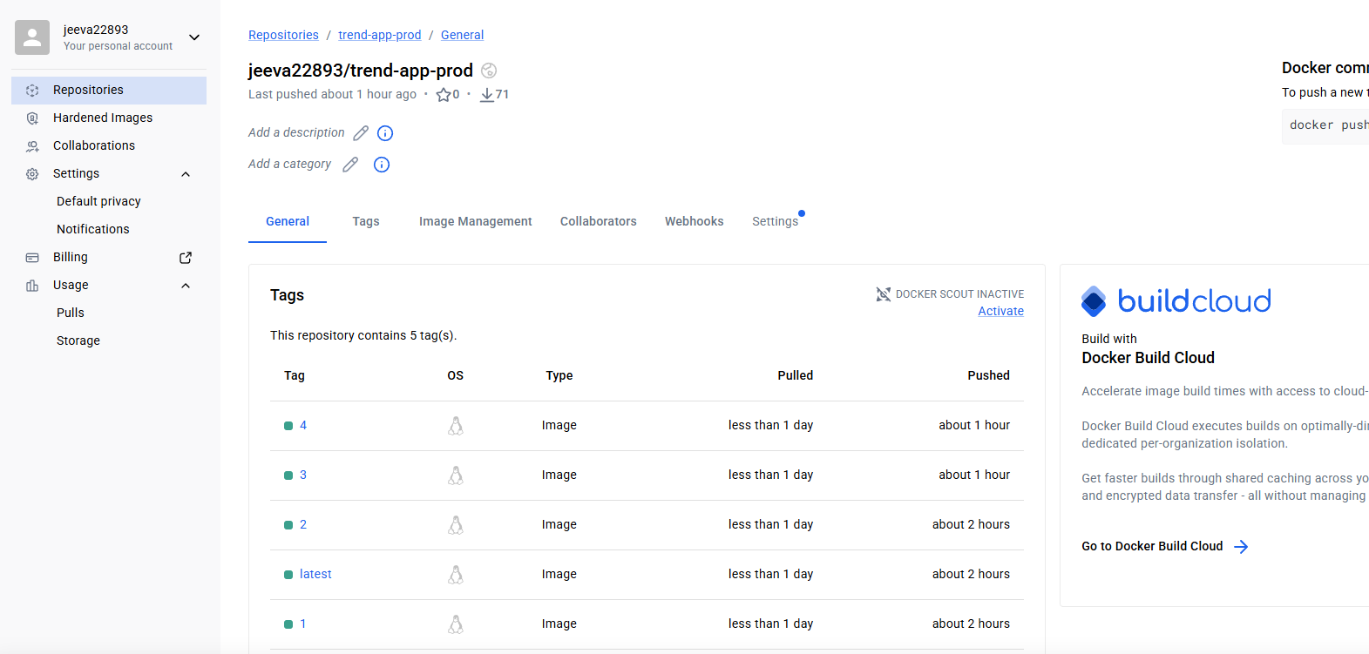

5. Deployed Site
Browser screenshot of the live app at http://43.205.115.125 ]

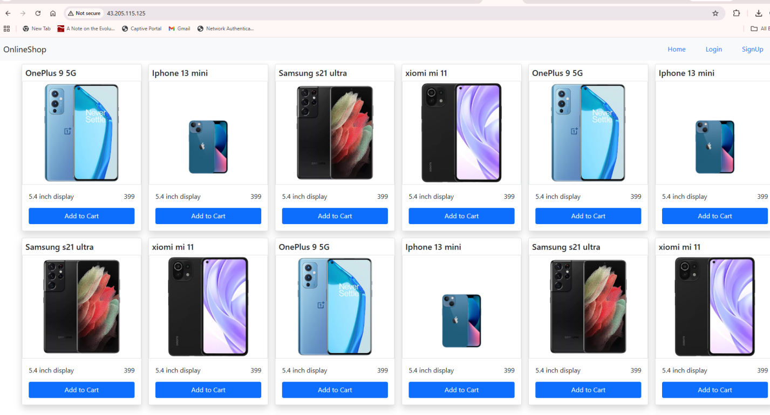

Monitoring — Health Check Status
Uptime Kuma dashboard showing the Trend App monitor status (Up) ]

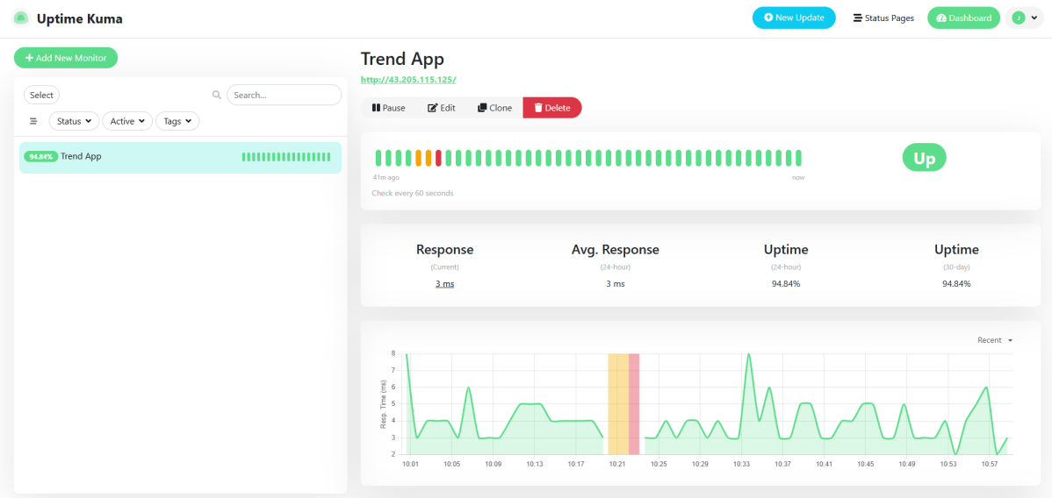
Notification configuration (Email) and/or a captured DOWN alert ]
